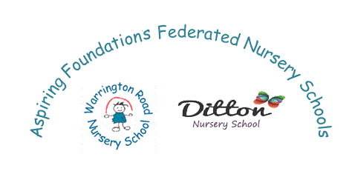
Halton Borough Council
Ditton Nursery School
Dundalk Road, Widnes, WA8 8DF.
Headteacher – Liane Johnson
Nursery School
Tele : 0151 424 4687
Email : sec.dittonnursery@halton.gov.uk

Pupil Application Form

Ditton Nursery School is a maintained nursery school, we offer places for children from the term after the child’s 3rd birthday. We offer a different range of activities and learning objectives to compliment the Early Years Foundation Stage.
There are many opportunities to play, explore and talk, which are the key processes for learning in the early years.
Currently we offer five mornings or afternoons 3 hour sessions and we also offer 30 hour places. We ensure that the same group of 13 children are together each day therefore helping them to make friends and to learn how to socialise etc. It also means that children get a consistent message; concepts can be introduced and developed over the course of the week.
Nursery school is staffed by four fully qualified teachers, three teaching assistants and various other support assistant staff.

Child’s Details
Surname | Legal Surname | First Name | Date of birth | Male/Female

Child’s Address
Postcode | Number/Name | Street | Town

Parental Responsibility
Contacts | Relationship | Surname | First Name | Home Contact | Mobile Contact

Email Contact

Additional Information
EAL (English as Additional Language) | Ethnicity | SEN (Special Educational Need) | Child in Care or Looked After

We will contact you with regards to your child starting nursery school the term before they are due to start. If you have any questions please contact the Office Manager on the above email or telephone number.
