Buddhist Monks Visit

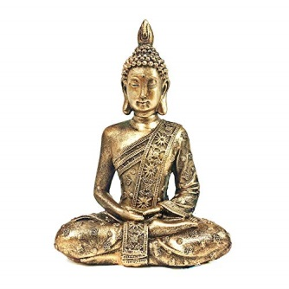

The children at Warrington Road Nursery School had a visit from a Buddhist Monk from The Wat Phra Singh, the Buddhist Temple in Runcorn. They told us about how Buddhists believe in being happy and not being sad or angry.

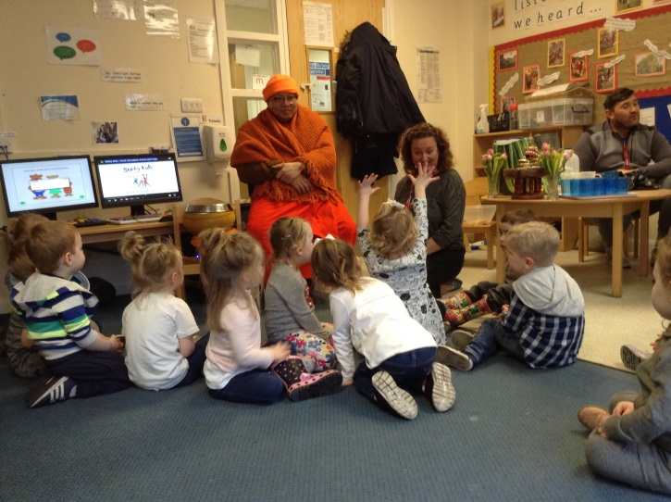

They do not own any possessions other than their robe and their alms bowl. We all put a biscuit in the bowl and he chanted for us wishing us health, happiness and a good life.

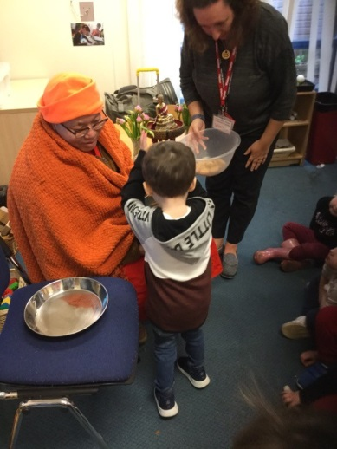

The children looked at the Buddha statue and heard about its meaning.

